**Task 7: Year 11: Investigation Ohmic – Non-Ohmic Circuits**

**Validation Test**

Name _________________________ Mark ________________/ 14

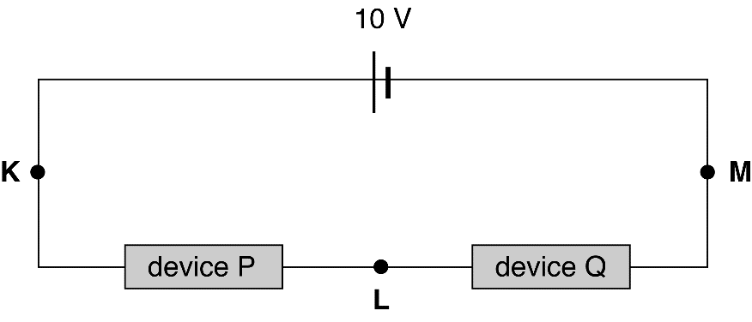Two electrical devices are connected in a series circuit as shown in the following diagram. The battery has zero internal resistance and the current at point K is 100 mA.

a Determine the current at point L?

Since current is constant at all points in a series circuit at point L, I = 100 mA. (2 marks)

The current–voltage characteristics for these two devices are shown in the graphs below.

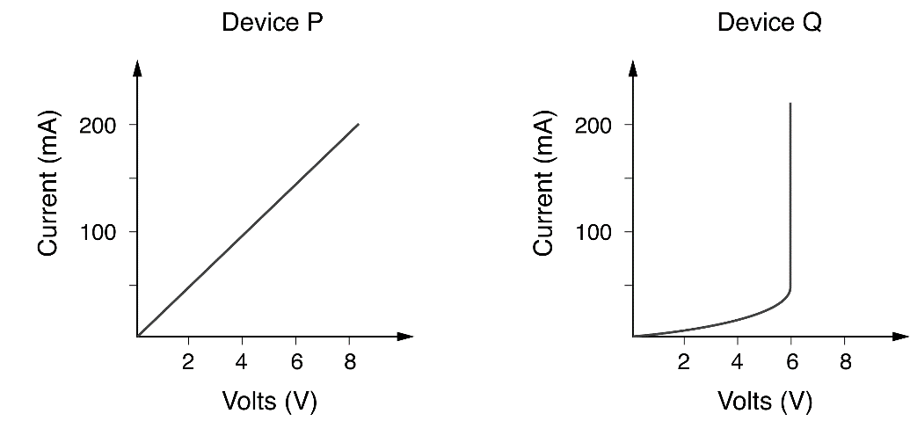

b Calculate the potential difference between points K and L.

The potential difference between points K and L is the same as the potential difference across device P. From the graph for device P, when I = 100 mA, V = 4.00 V. (2 marks)

c Determine the potential difference between points L and M.

The potential difference between points L and M is the same as the potential difference across device Q. *(Use graph or calculation)*  
From the graph for device Q, when I = 100 mA, V = 6.00 V. (2 mark)

or emf = VP + VQ   
10 = 4.00 + VQ

VQ = 10 – 4.00 = 6.00 V

d Determine the effective resistance of device Q when I is 100 mA?

From part c, when I = 100 mA = 0.100 A, V = 6.00 V. So:

 (2 marks)

e State which of these two components obeys Ohm’s law and explain your reasoning? (2 mark)

Device P, as its I–V graph is linear.

**f**. For the device you identified as ohmic , in part e, determine the gradient of the graph and use it to determine the resistance of the device .

 ( 2 marks)

 

 (2 marks)